WORKSHOP # 25

University of the Armed Forces ESPE

Computer Science Department

Software Engineering



ADVANCE WEB DEVELOP

NRC 2296

06/11/2024

1. Asmal Kevin

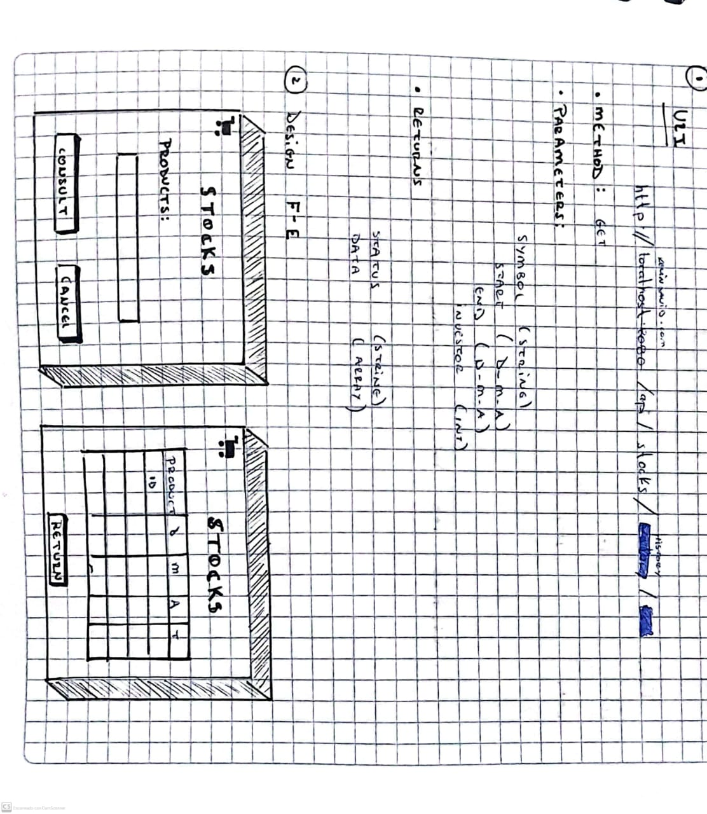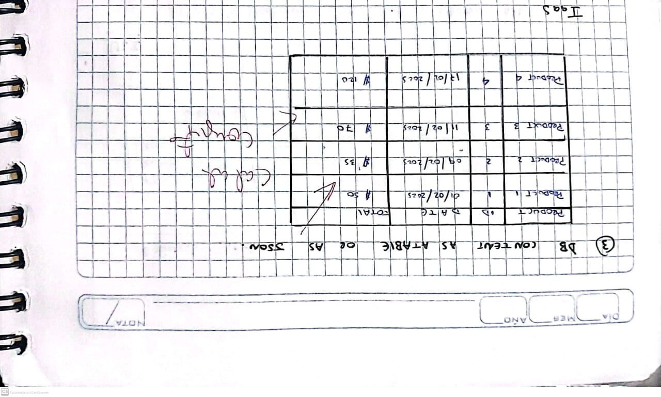

1. Casignia Diego

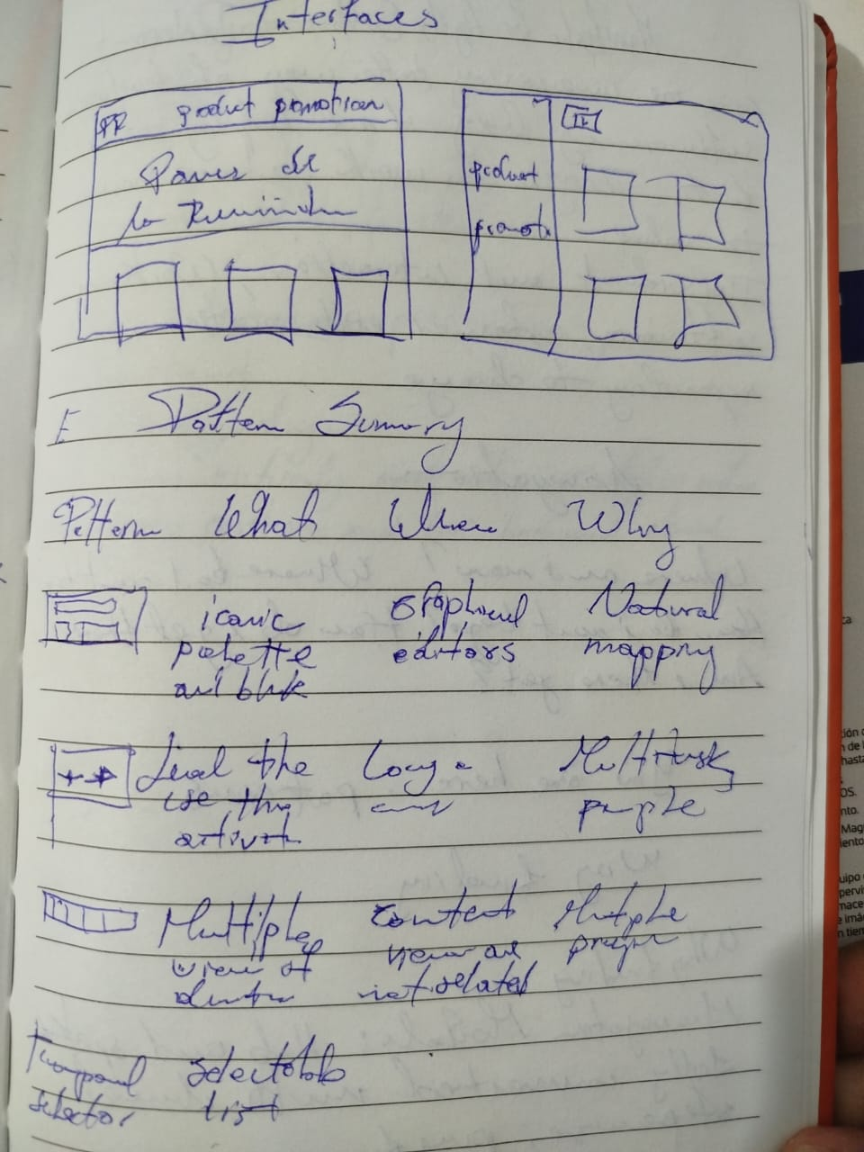

1. Chavez Kleber
2. Chiliquinga Yeshua

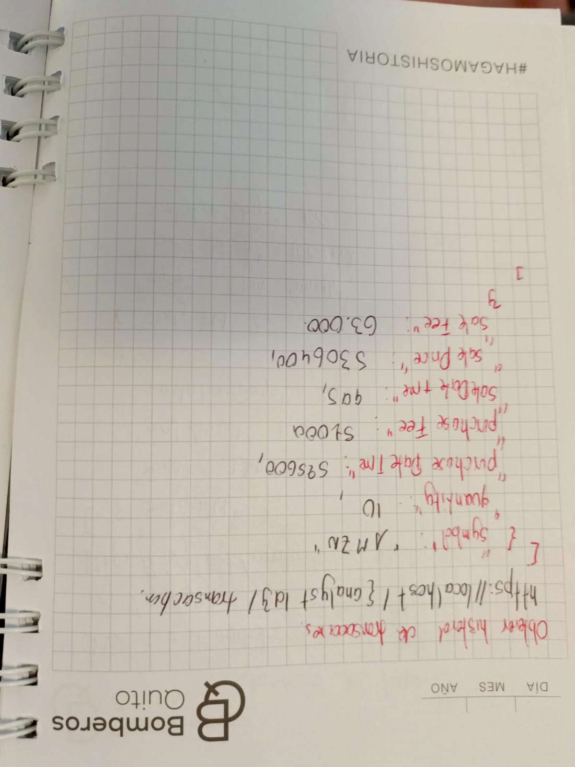

1. Cuadrado Alejandro

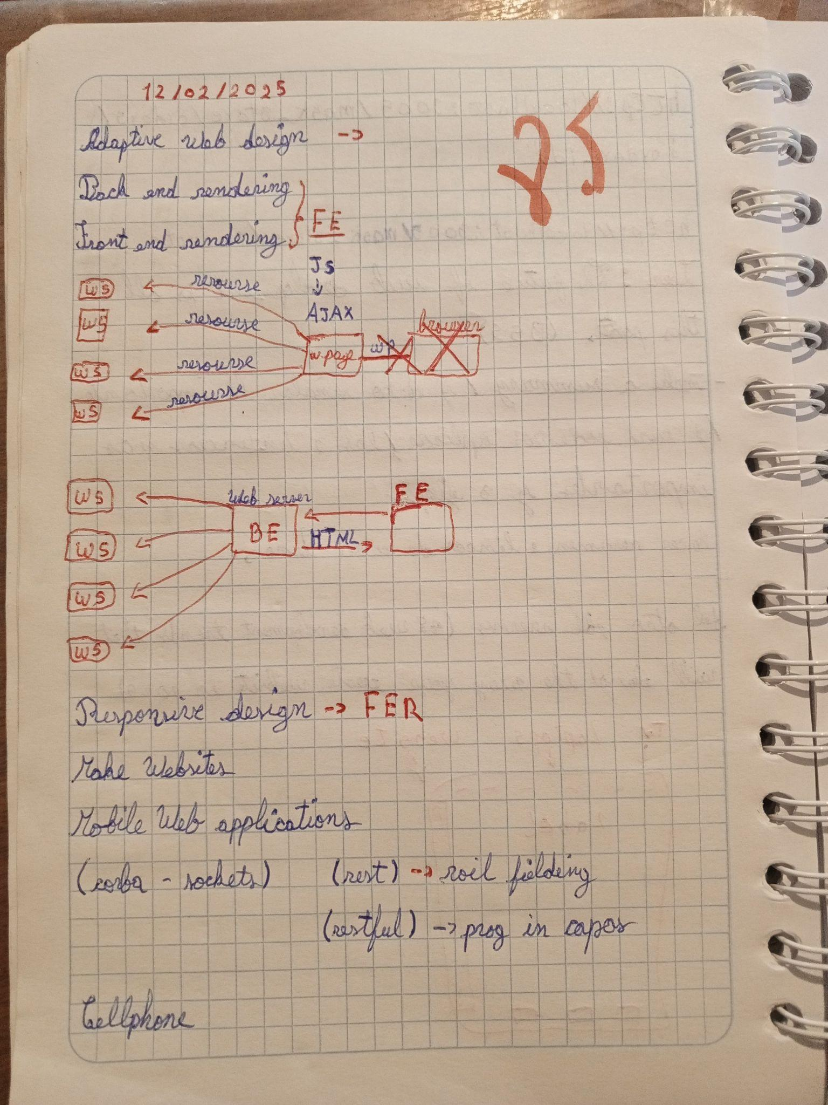

1. Escobar Isaac
2. Espin Andres
3. Gualichico Josue
4. Jaya Carlos

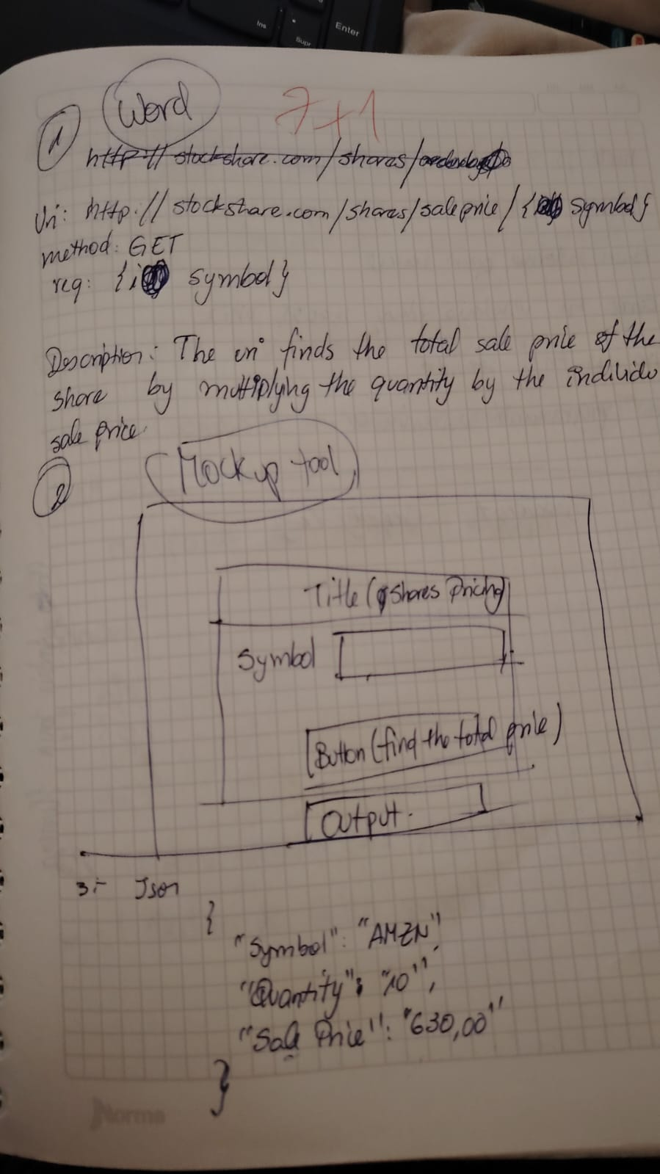

1. Lugmaña Matias
2. Marin Josue

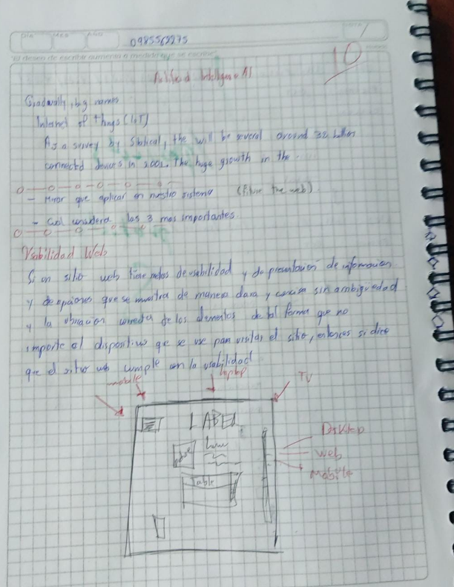

1. Orrico Camilo

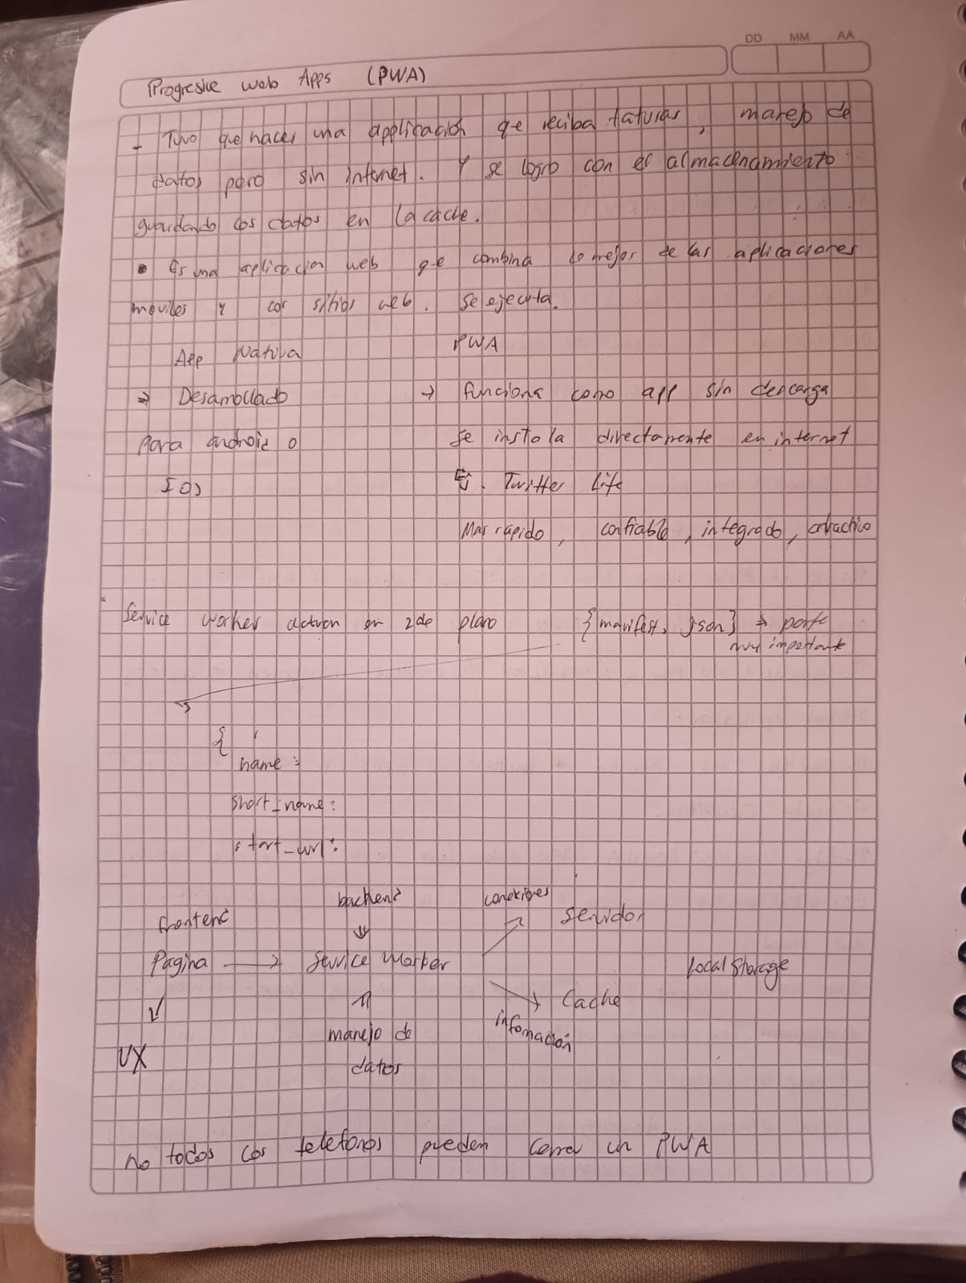

1. Pabon Elkin

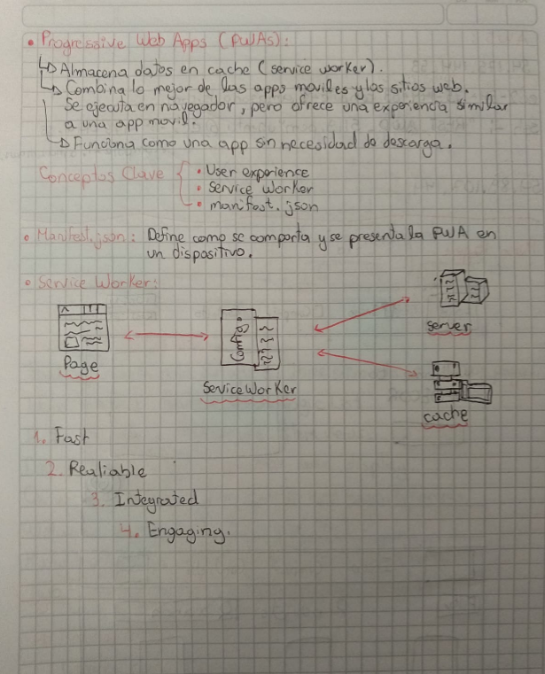

1. Darwin Panchez

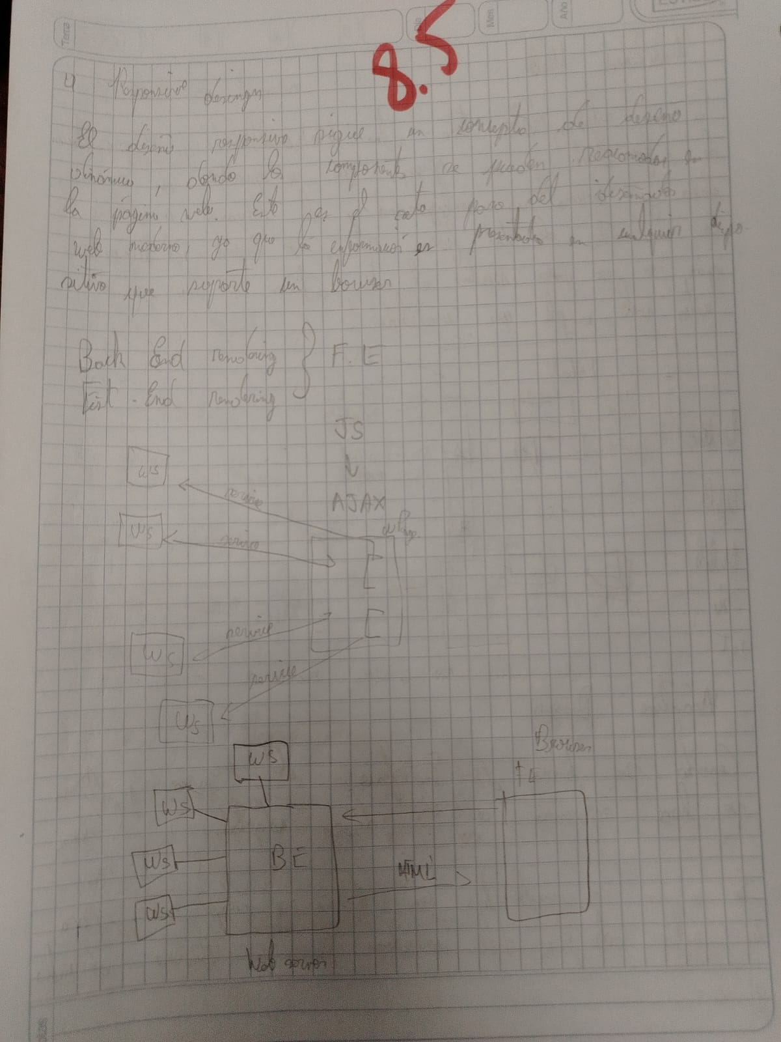

1. Proaño Jose

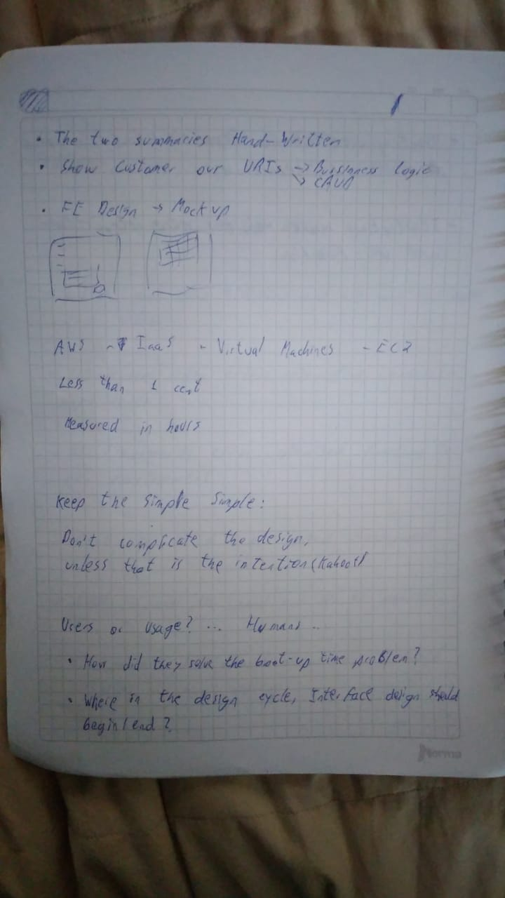

1. Salcedo Micaela

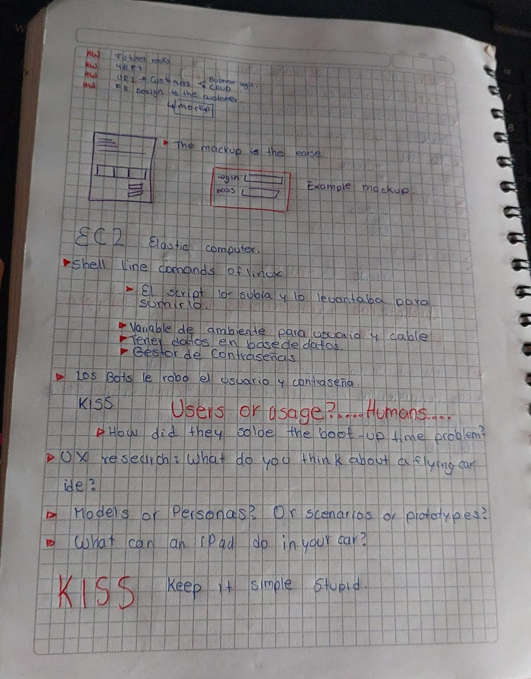

1. Sanmartin Jose

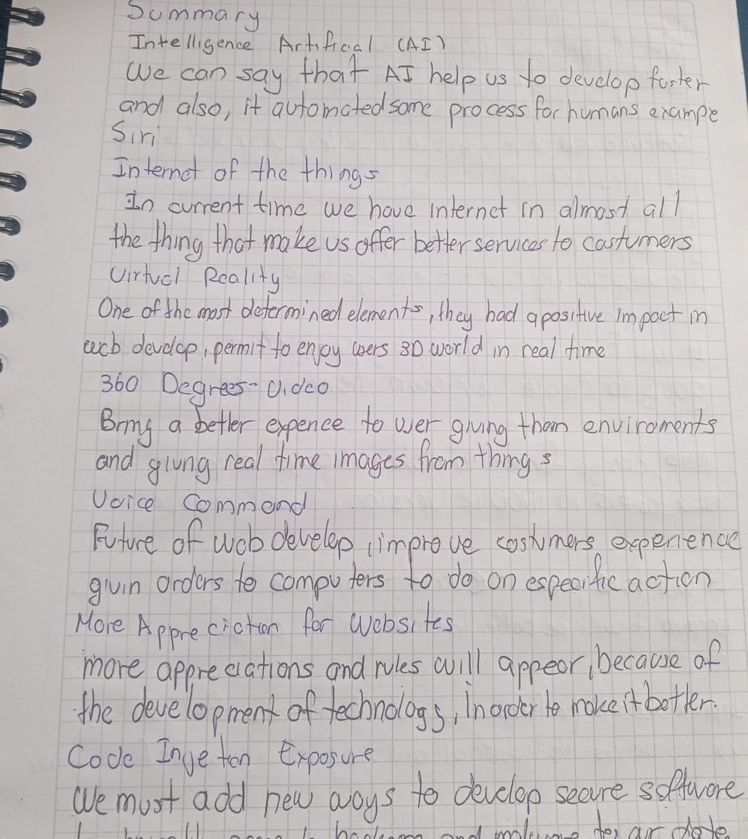

1. Suarez Matias

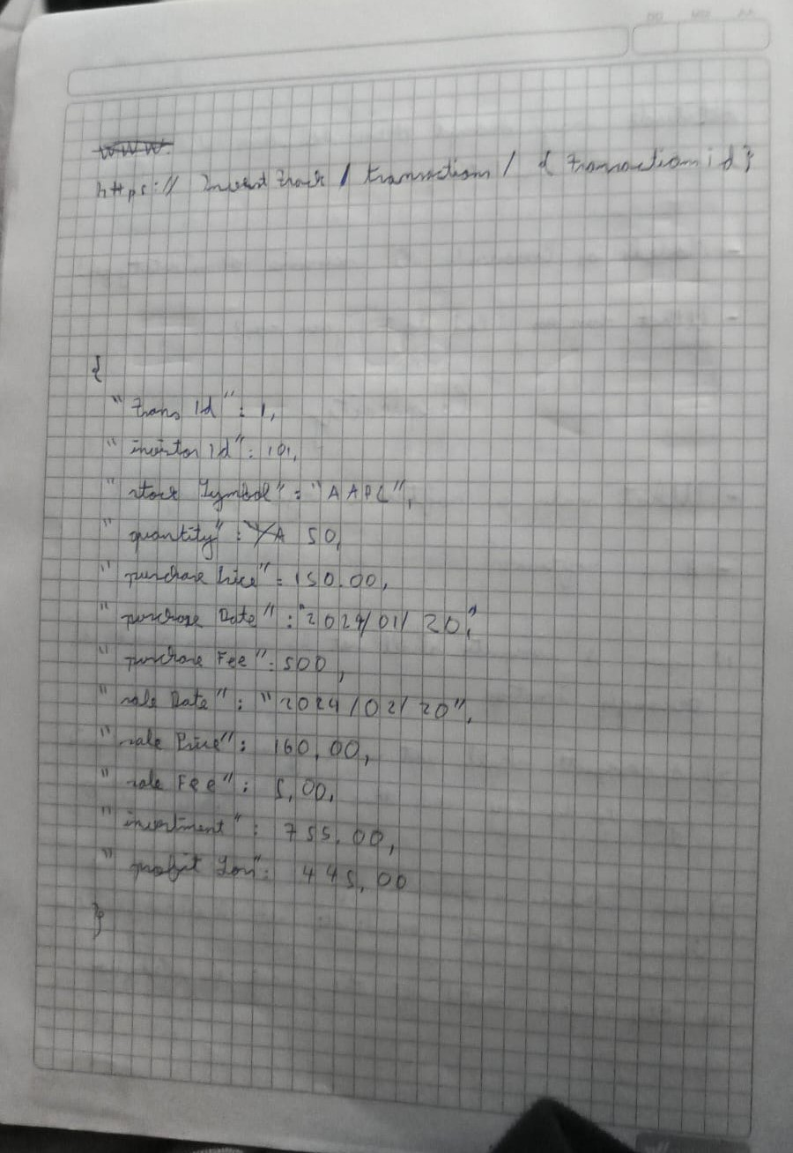

1. Villaroel Justin